|  |  |  |  |
| --- | --- | --- | --- |
| **Supplementary Material A.** Composition of parliament in the Netherlands (2017) | | | |
| **Political Party** | **social dimension** | **N / mean** | **prop. / SD** |
|  | *gender* |  |  |
| parliament | male | 96 | 0.64 |
| parliament | female | 54 | 0.36 |
| parliament | *age* | 45.13 | 9.32 |
| parliament | *minority status* |  |  |
| parliament | no visible minority | 134 | 0.89 |
| parliament | visible minority | 16 | 0.11 |
| parliament | *political party* |  |  |
| parliament | VVD: People's party for Freedom and Democracy | 33 | 0.22 |
| parliament | PVV: Party for Freedom | 20 | 0.13 |
| parliament | CDA: Christian Democratic Appeal | 19 | 0.13 |
| parliament | D66: Liberal Democrats | 19 | 0.13 |
| parliament | GroenLinks: GreenLeft | 14 | 0.09 |
| parliament | SP: Socialist Party | 14 | 0.09 |
| parliament | PvdA: Labour Party | 9 | 0.06 |
| parliament | CU: Christian Union | 5 | 0.03 |
| parliament | Partij voor de Dieren: Party for the Animals | 5 | 0.03 |
| parliament | 50Plus: 50Plus | 4 | 0.03 |
| parliament | DENK: THINK | 3 | 0.02 |
| parliament | SGP: Reformed political Party | 3 | 0.02 |
| parliament | FvD: Forum for Democracy | 2 | 0.01 |
|  | *gender* |  |  |
| VVD | male | 23 | 0.70 |
| VVD | female | 10 | 0.30 |
| PVV | male | 14 | 0.70 |
| PVV | female | 6 | 0.30 |
| CDA | male | 13 | 0.68 |
| CDA | female | 6 | 0.32 |
| D66 | male | 12 | 0.63 |
| D66 | female | 7 | 0.37 |
| GroenLinks | male | 6 | 0.43 |
| GroenLinks | female | 8 | 0.57 |
| SP | male | 9 | 0.64 |
| SP | female | 5 | 0.36 |
| PvdA | male | 4 | 0.44 |
| PvdA | female | 5 | 0.56 |
| CU | male | 3 | 0.60 |
| CU | female | 2 | 0.40 |
| PvdDieren | male | 2 | 0.40 |
| PvdDieren | female | 3 | 0.60 |
| 50Plus | male | 2 | 0.50 |
| 50Plus | female | 2 | 0.50 |
| DENK | male | 3 | 1.00 |
| SGP | male | 3 | 1.00 |
| FvD | male | 2 | 1.00 |

*Supplementary Material A. continued*

|  |  |  |  |
| --- | --- | --- | --- |
|  | *age* |  |  |
| VVD | age | 44.03 | 6.72 |
| PVV | age | 46.05 | 10.09 |
| CDA | age | 44.79 | 7.84 |
| D66 | age | 43.84 | 10.16 |
| GroenLinks | age | 47.14 | 10.08 |
| SP | age | 38.36 | 6.99 |
| PvdA | age | 44.89 | 7.99 |
| CU | age | 46.80 | 4.38 |
| PvdDieren | age | 45.20 | 8.26 |
| 50Plus | age | 64.75 | 8.02 |
| DENK | age | 42.33 | 5.51 |
| SGP | age | 52.33 | 7.57 |
| FvD | age | 53.50 | 27.58 |
|  | *minority status* |  |  |
| VVD | no visible minority | 30 | 0.91 |
| VVD | visible minority | 3 | 0.09 |
| PVV | no visible minority | 19 | 0.95 |
| PVV | visible minority | 1 | 0.05 |
| CDA | no visible minority | 18 | 0.95 |
| CDA | visible minority | 1 | 0.05 |
| D66 | no visible minority | 17 | 0.89 |
| D66 | visible minority | 2 | 0.11 |
| GroenLinks | no visible minority | 11 | 0.79 |
| GroenLinks | visible minority | 3 | 0.21 |
| SP | no visible minority | 12 | 0.86 |
| SP | visible minority | 2 | 0.14 |
| PvdA | no visible minority | 8 | 0.89 |
| PvdA | visible minority | 1 | 0.11 |
| CU | no visible minority | 5 | 1.00 |
| PvdDieren | no visible minority | 5 | 1.00 |
| 50Plus | no visible minority | 4 | 1.00 |
| DENK | visible minority | 3 | 1.00 |
| SGP | no visible minority | 3 | 1.00 |
| FvD | no visible minority | 2 | 1.00 |

Note. After the 2017 elections, women were underrepresented in Parliament (54 MPs, 36%) and in most factions, women hold a numerical minority position. The mean age of MPs in Parliament does slightly deviate downwards from the mean age in the general Dutch electorate (45 versus 50). There are striking age composition differences across parties. The MPs of the Senior Interest Party 50Plus, have a mean age of 65 year. The mean age of MPs of the radical left Socialist Party (‘SP’) is just over 38. In The Netherlands, the share of MPs with a visible ethnic-minority background reflects the share of ethnic-minority citizenships of the electorate fairly well. But once again, we observe marked differences across parties.

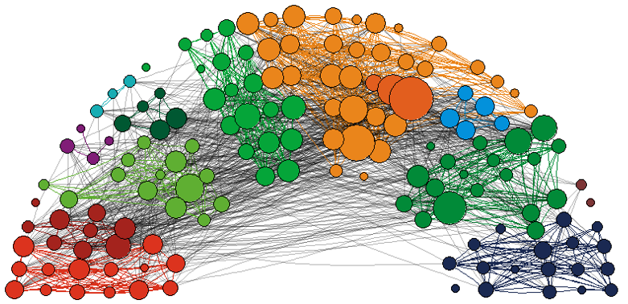

**Panel a.** Follower relations

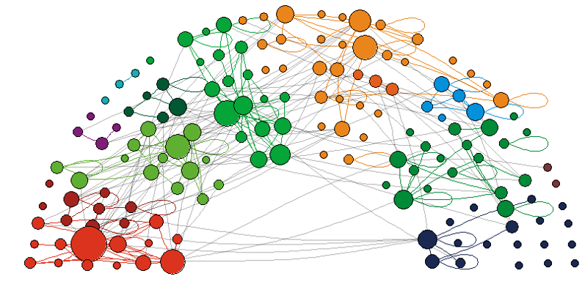

**Panel b.** @-mentions

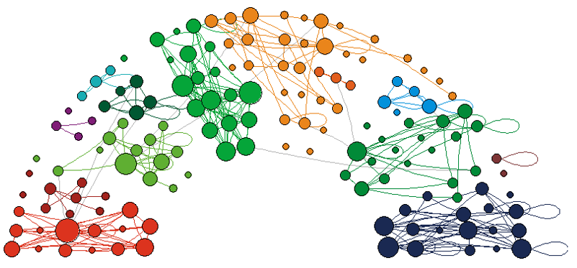

**Panel c.** Retweets

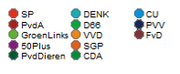

**Supplementary Material B.** Reciprocated twitter relations between Dutch MPs (2017)

*Notes: Node size based on degree. Edge color based on Party affiliation, black if MPs from different party*

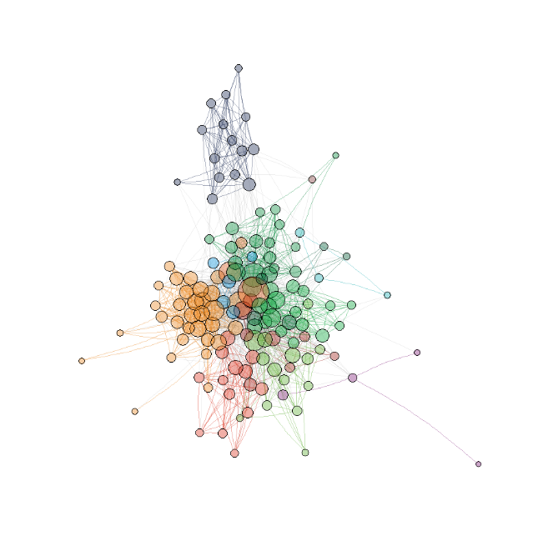

**Panel a.** Follower relations

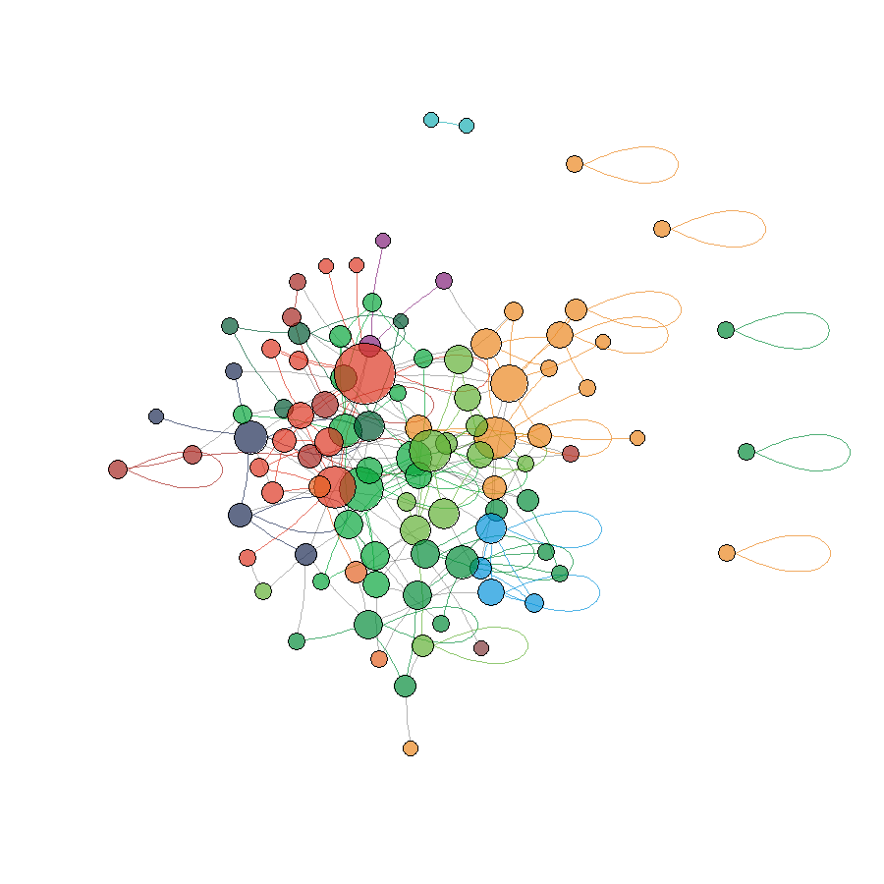

**Panel b.** @-mentions

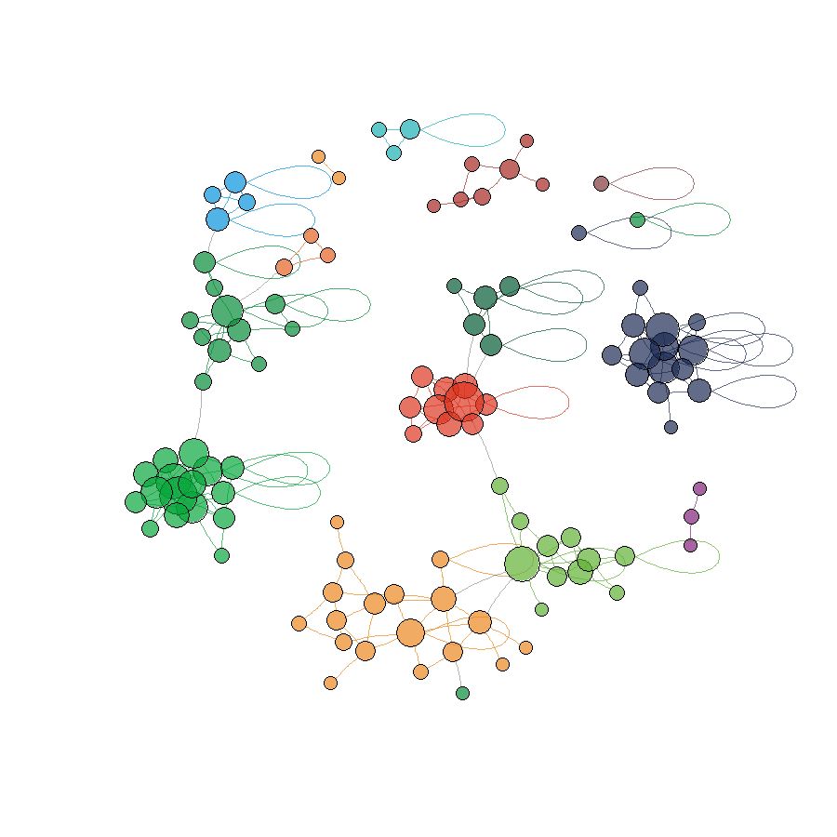

**Panel c.** Retweets



**Supplementary Material C.** Reciprocated twitter relations between Dutch MPs (2017)

*Notes: Position based on Fruchterman-Reingold algorithm. Node size based on degree. Edge color based on Party affiliation, black if MPs from different party. Isolates removed.*

|  |  |  |  |  |  |  |
| --- | --- | --- | --- | --- | --- | --- |
| **Supplementary Material D.** Multiplex RSiena model to predict twitter relations among (147) Dutch MPs in 2017: full results Model 1 | | | | | | |
|  | b | se | b | se | b | se |
|  | *following* | | *@-mentions* | | *retweets* | |
| *rate parameters* |  |  |  |  |  |  |
| period 1 (April – June) | 4.626 | 0.293 | 66.540 | 48.362 | 18.468 | 1.760 |
| period 2 (June – September) | 2.035 | 0.130 | 13.365 | 0.943 | 17.263 | 1.437 |
| *structural effects* |  |  |  |  |  |  |
| outdegree | -13.307 | 1.871 | -4.215 | 0.140 | -3.923 | 0.164 |
| reciprocity | 0.847 | 0.114 | 1.402 | 0.090 | 0.615 | 0.094 |
| transitive triplets | 0.037 | 0.007 | 0.066 | 0.036 | 0.157 | 0.025 |
| shared popularity | -0.001 | 0.000 | -0.008 | 0.010 | -0.014 | 0.005 |
| indegree - popularity (sqrt) | 0.351 | 0.062 | 0.395 | 0.051 | 0.393 | 0.045 |
| outdegree - popularity (sqrt) | -0.186 | 0.034 | -0.096 | 0.039 | -0.271 | 0.059 |
| outdegree - activity (sqrt) | 1.328 | 0.250 | 0.256 | 0.025 | 0.162 | 0.027 |
| *ego characteristics* |  |  |  |  |  |  |
| Liberal Democrats |  |  |  |  | -0.427 | 0.074 |
| Populist Radical Right |  |  |  |  | -0.180 | 0.084 |
| Green party |  |  | 0.135 | 0.070 |  |  |
| party leader |  |  | -0.300 | 0.096 |  |  |
| incumbent |  |  |  |  | -0.114 | 0.045 |
| position on election ballot | 0.542 | 0.154 |  |  |  |  |
| *alter characteristics* |  |  |  |  |  |  |
| Liberal Democrats |  |  | -0.104 | 0.071 |  |  |
| Green party |  |  | -0.171 | 0.084 |  |  |
| Incumbent | -0.507 | 0.087 |  |  | -0.082 | 0.046 |
| position on election ballot |  |  | -0.012 | 0.003 | -0.012 | 0.004 |
| party leader |  |  | 0.129 | 0.092 | 0.122 | 0.079 |
| *dyad characteristics* |  |  |  |  |  |  |
| same incumbency status | 0.165 | 0.083 |  |  |  |  |
| seating distance | -0.022 | 0.007 |  |  | -0.031 | 0.006 |
| same party | 1.083 | 0.146 | 0.918 | 0.054 | 1.386 | 0.078 |

*Notes:* Overall maximum convergence ratio: 0.2471; parameter estimates with a *t-value < 1* have been dropped.